**Effect of CO2 Emissions on Urban Population**

Carbon Di-Oxide is one of the renowned greenhouse gas that is emitted from different industries and factories while producing goods and products. It has a great impact on weather and climate change. If the amount of Carbon Di-Oxide will be increased, the temperature will rise in the climate and this will affect the livelihood of the people. The production of Carbon Di-Oxide is not the same for all countries. To understand the statistics of Carbon Di-Oxide emission and the impact on the Urban population, the data has been fetched from World Bank using the relevant indicators. In this context, the following indicators have been selected for the following countries:

* Urban population
* CO2 emissions (kt)
* France
* Iraq
* Argentina
* Brazil
* China
* World

The Carbon Di-Oxide is also emitted by the household and private works like cooking and driving. It is also the significant outcomes of the road traffic and transport. The statistics of the World Bank show the following fact:

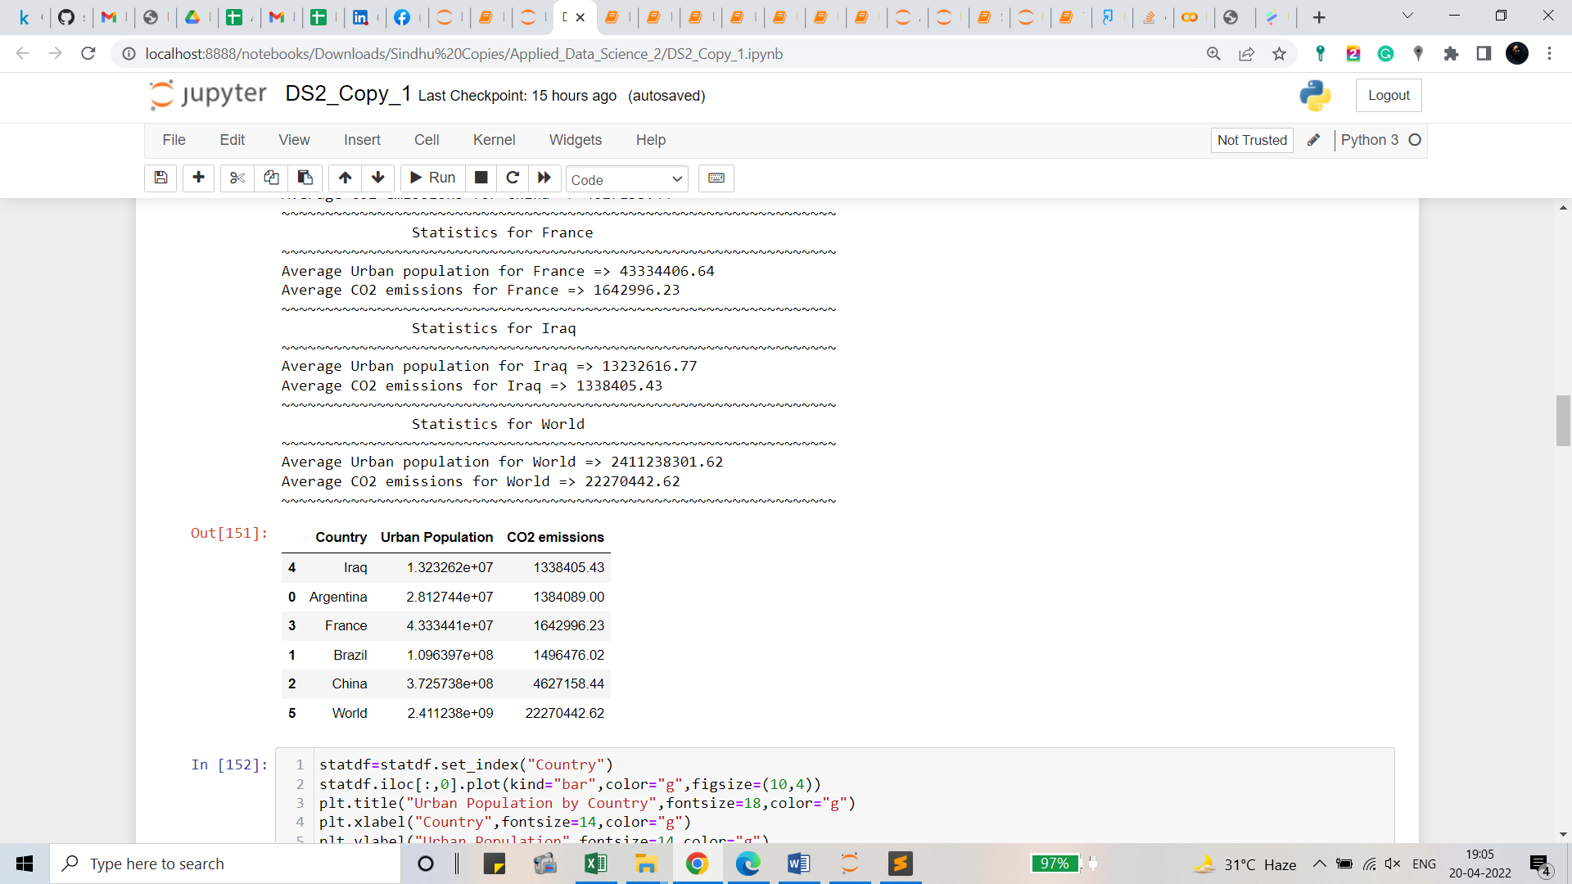

To identify the statistics, the average value of the urban population and the emotion of CO2 have been taken. So, the statistics show the relevant outcomes of the average value of the urban population and the emotion of CO2. To understand the statistics, bar char has been chosen as the visualization. The bar chart will provide the visual perception of the values by the countries and world data. The visualization for the outcomes by countries and world are shown below:

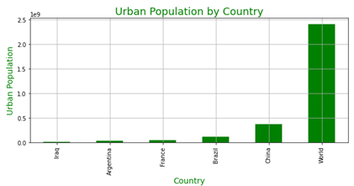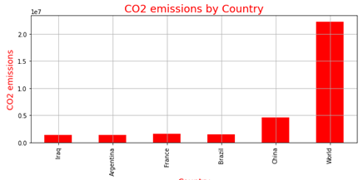

From the visualization, it can be seen that the urban population has a relationship with the emotion of carbon-di-oxide. So, to visualize the relationship, a correlation measure has been applied. Correlation is the statistical measure through which relation between two features (here the urban population and co2 emission by countries) can be determined. The correlation values have been shown using the heatmap as it shows the values of correlation through a colour scheme. The heatmap for the correlation is shown below:

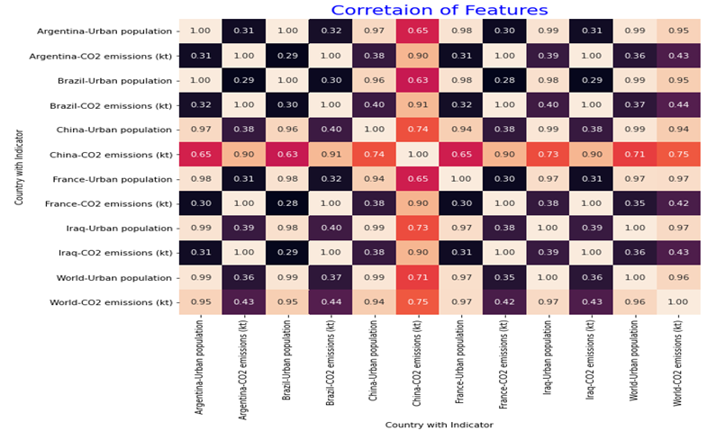

From the correlation chart, it can be seen that the correlation between the two features is changing by country. For example, for Argentina, it is 0.31, for Brazil, it is 0.3, for China, it is 0.4. So, the relationship is changing among countries because of the value of the urban population and the amount of co2 emission. In the context of world value, it is 0.96. So, the relationship of variables by country and for the world is totally different. The final visualization of the urban population and co2 emissions by year are shown below for all selected countries through a line chart:

